Week Ending: |  | DAY: |  |  | Subject: Mathematics
Duration: 60mins per lesson |  |  |  |  | Strand: Number
Class: B6 |  | Class Size: |  |  | Sub Strand: Ratio And Proportion
Content Standard:  B6.1.4.2 Understand the concept of proportion and its relationship to ratios and rates. Use proportional reasoning and rates to solve real world and mathematical problems |  |  |  | Indicator:  B6.1.4.2.3 Use various strategies to solve proportional reasoning problems involving rates and scales |  |  | Lesson:  1 OF 1
Performance Indicator:  Learners can use various strategies to solve proportional reasoning problems involving rates and scales |  |  |  |  |  | Core Competencies:  Problem Solving skills; Critical Thinking;
Teaching/ Learning Resources |  |  | Counters, bundle and loose straws
Key words
References: Mathematics Curriculum Pg. 137
DAYS | PHASE 1: STARTER | PHASE 2: MAIN | PHASE 3: REFLECTION
Monday | Take learners through math mental to solve the following.  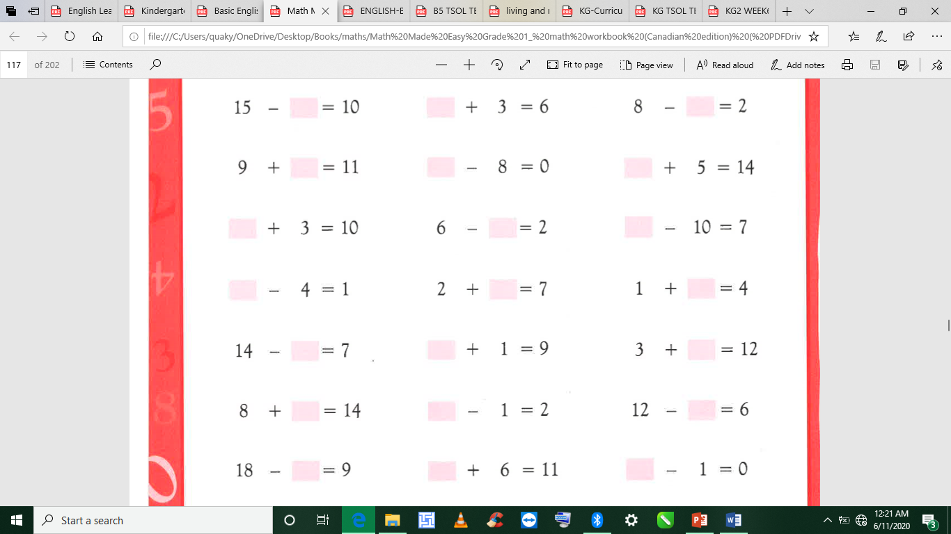 | Guide learners to use diagrams to explain the concept of rate a ratio that compares two different quantities measured in different units;  e.g. the ratio → cost:  weight = 8:2 = 4:1.  This ratio is the unit ratio and show the rate for selling a unit or 1kg of the meat. | Give learners task to complete whiles you go round to guide those who don’t understand.  Give remedial learning to those who special help.
Tuesday | Take learners through math mental to solve the following. | Guide learners to work out rates and use them in solving problems.  E.g. A litre of sachet water costs 40p. Find the cost of  (i) 12 litre (ii) 7 liters (iii) 9 liters | Give learners task to complete whiles you go round to guide those who don’t understand.  Give remedial learning to those who special help.
Wednesday | Take learners through math mental to solve the following. | Learners to use diagrams to explain the concept of scale as a ratio that compares two different sizes – an object and its model;  e.g. plan of a house or room. Here is the plan of a bedroom. The scale is 1:100, which means that 1cm in the drawing represents 100 cm in the actual room. What is the actual length of  (i) the room if it measures 41 2 cm;  (ii) the bed if it measures 1.8cm?] | Give learners task to complete whiles you go round to guide those who don’t understand.  Give remedial learning to those who special help.
Thursday | Take learners through math mental to solve the following. | Learners to use diagrams to explain the concept of scale as a ratio that compares two different sizes – an object and its model;  e.g. plan of a house or room. Here is the plan of a bedroom. The scale is 1:100, which means that 1cm in the drawing represents 100 cm in the actual room. What is the actual length of  (i) the room if it measures 41 2 cm;  (ii) the bed if it measures 1.8cm?] | Give learners task to complete whiles you go round to guide those who don’t understand.  Give remedial learning to those who special help.
Friday | Take learners through math mental to solve the following. | Work out scales and use them in solving problems; e.g. If 10cm on a map stands for 10km, what distances on the map stands for (i) 1km (ii) 7km (iii) 41km? | Give learners task to complete whiles you go round to guide those who don’t understand.  Give remedial learning to those who special help.

